**SOFTWARE REQUIREMENT FOR GROUP DISCUSSION SLOT BOOKING SYSTEM**

|  |  |
| --- | --- |
| **Name** | **VISHAL K** |
| **Roll number** | **7376222CT160** |
| **Seat number** | **280** |
| **Project ID** | **40** |
| **Problem statement** | **GROUP DISCUSSION SLOT BOOKING SYSTEM** |

**PROBLEM STATEMENT: GROUP DISCUSSION SLOT BOOKING SYSTEM**

The purpose of the project is to create a centralized platform for managing Group Discussion (GD) sessions, mock interviews, and self-introduction sessions, allowing users to efficiently book slots based on their availability and preferences. This system aims to streamline administrative tasks such as schedule management, notification handling, and venue assignment, ultimately enhancing coordination between users and faculty while optimizing resource allocation.

**STACK:**

|  |  |
| --- | --- |
| **Component** | **Tech Stack** |
| **Frontend** | **Angular js** |
| **Backend** | **Node js with Express js** |
| **Database** | **MongoDB** |
| **API** | **REST Full API** |

**PROGRESS - TIMELINE:**

|  |  |  |  |
| --- | --- | --- | --- |
| **Phase** | **Deadline** | **Status** | **Notes** |
| **Stage 1** | **03/05/2024** | **In Progress** | **Planning and Requirement Gathering** |
| **Stage 2** |  | **Not Started** | **Design and Prototyping** |
| **Stage 3** |  | **Not Started** | **DB Designing** |
| **Stage 4** |  | **Not Started** | **Backend Implementation** |
| **Stage 5** |  | **Not Started** | **Testing & Implementation** |
| **Stage 6** |  | **Not Started** | **Deployment** |

1. **INTRODUCTION:**

**1.1 PURPOSE:**

Develop a portal for Group Discussion (GD) allowing users to book slots for GD sessions, mock interviews, and self-introduction sessions. Users log in using email IDs, authenticated with Bitsathy mail. Slots are categorized into batches (Batch 1 - Batch 4). Admin sets weekly schedules, and the student books slots with respective faculty. All the slots booked by student should be accessible by the faculty.

**1.2 SCOPE OF THE PROJECT:**

The creation of a user-friendly web-based platform customized to meet the unique requirements of BIT students and alumni is included in the scope of the Group Discussion Slot Booking System. Within the BIT community, the portal will be efficient for quick and easy slot bookings for student, reducing the work pressure of the faculty.

* **Admin Access:** Fix Weekly Schedules specifying available slots for Mock Group Discussion, Mock Interviews, and Mock Self-Introduction. Admin can view the list of students who have booked slots and those who missed their slots.
* **User Access:** Users can view available slots for Mock Group Discussion, Mock Interviews, and Mock Self-Introduction in the given week. Users can select slots based on their batch and preferred timing.
* **Venue Selection:** Users can choose IT Conference Hall, CSE Conference Hall and Training and Placement halls preferred by admin as the venue for their sessions.
* **Number of Students per Slot:** ForGroup Discussion each slot can accommodate up to 10 students. For Mock Interviews each slot is reserved for 1 student. For Self-Introduction each slot can accommodate up to 2 students.
* **Notification Management:** Users receive notifications for successfully booked slots to remind them of the upcoming session and notifications for missed slots to reschedule or seek further instructions.

### **1.3. TECHNOLOGY STACK:**

* **Frontend:** Angular.js for a dynamic and responsive user interface.
* **Backend:** Node.js with Express for server-side logic; Python could also be considered for its robustness in handling data.
* **Database**: MongoDB depending on the requirement for scalability and data structure flexibility.
* **API:** REST Full API

### 

1. **STACK OVERVIEW:**

### **2.1 Purpose of the System****:**

### The purpose of the system is to streamline the organization of Group Discussion (GD), mock interviews, and self-introduction sessions. It aims to provide users with a convenient platform to book slots based on their availability and preferences while ensuring efficient allocation of resources. The faculty facilitates administrative tasks such as schedule management, notification handling, and venue assignment, enhancing overall coordination and effectiveness.

### **2.2 System Components:**

1. **User Interface (UI):**
   * **Web Interface:** A responsive web application that provides users with access to all platform features from various devices (desktops, tablets, and smartphones).
2. **Backend Services:**
   * **Authentication Service**: Responsible for user authentication using Bitsathy mail authentication.
   * **Schedule Management Service:** Allows admins to set weekly schedules for GD, mock interviews, and self-introduction sessions.
   * **Slot Booking Service:** Manages user bookings for available slots. Ensures that slots are categorized by batch and type of session (GD, mock interviews, self-introduction).
   * **Notification Service**: Sends notifications to users and admins for booked slots and missed slots. Handles email notifications to remind users of their upcoming sessions and notifies admins of missed sessions.

**3. FUNCTIONAL REQUIREMENT:**

Functional requirements define specific behaviors or functions of a system. For a project like the " Group Discussion Slot Booking System", which aims to replicate and tailor some of the functionalities of a best slot booking application to a specific audience, these requirements detail what the system should do in terms of features and operations.

**3.1. User Authentication:**

Users should be able to log in using their email IDs authenticated with Bitasthy mail authentication.

**3.2. Slot Booking:**

Users should be able to view available slots for GD, mock interviews, and self-introduction. They should be able to select a slot based on their batch, timing, and preferred session type.

**3.3. Admin Features:**

Admin should be able to set weekly schedules for each session type (GD, mock interviews, self-introduction). Admin should have the ability to view all booked slots and missed slots, along with the respective students. Admin should be able to assign faculty to each slot.

**3. 5. Notification System:**

Users and admin should receive notifications for successful slot bookings. Users and admin should receive notifications for missed slots, prompting rescheduling or follow-up actions.

**PROTOTYPE OF THE PROJECT:**

**1.User Flow Chart:**

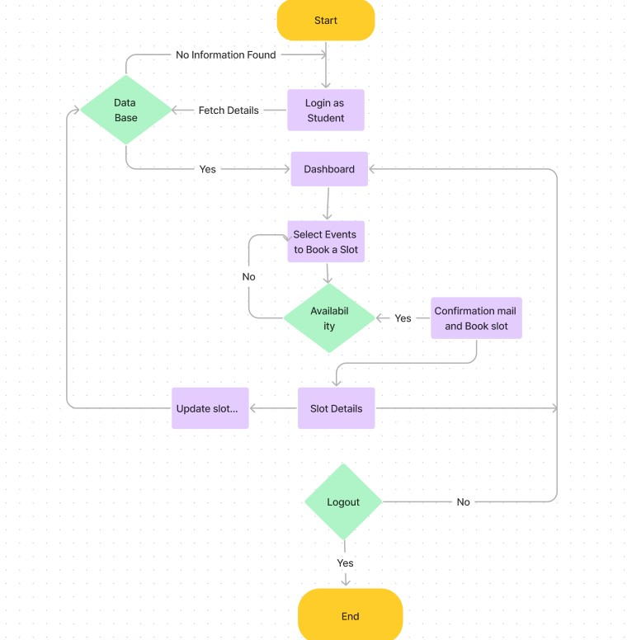

**2. Admin flow chart:**

